**Classroom Activity: Make your portfolio website responsive**

**Code:**

|  |
| --- |
| @media (max-width: 768px) {      nav ul li {          display: block;          margin: 5px 0;      }    } |

**Output:**

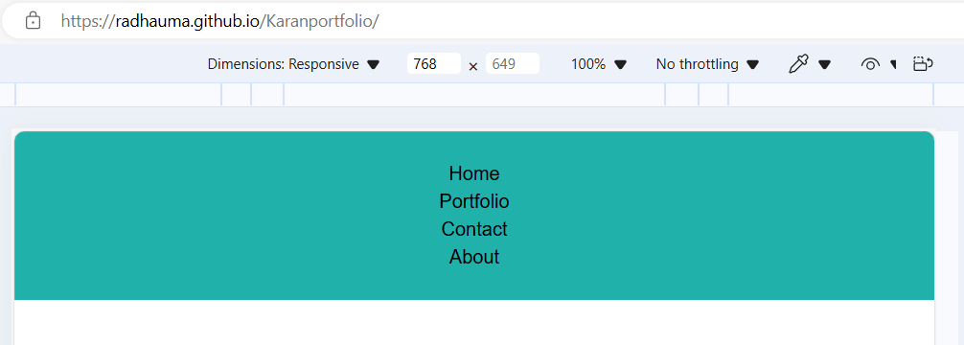

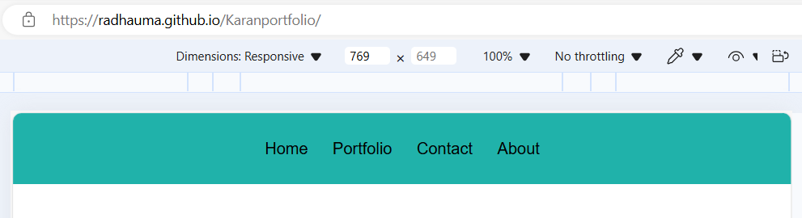

**Execution Steps:**

* Step 1: Set Up Your Project Directory
* Open Visual Studio Code.
* Create a new folder for your project, e.g., PortfolioProject.
* Step 2: Create the file name eg.)style.css
* Write a code to make a website responsive.
* Step 3: Click on Go Live.
* Step 4: Then it automatically takes up to the browser page.
* Step 5: Select Inspect
* Step 6: Get the idea of the code.